Lab 5

Dr. Ryan Gerdes

ECE 3710

By: Jonathan Tousley

Partner: Aaron Kunz

**Overview:**

The microcontroller was configured to interface with an LCD touchscreen. The screen would display 3 boxes and upon being touched would turn each box would turn its respective LED on and off. For operation, this project requires:

- A 5V voltage source for the LCD touchscreen (3.3 volts gave inconsistent results)

- The LCD touchscreen

- Lots of wires

**Hardware details:**

The microcontroller was connected to the LCD touchscreen using MCU 8080-II series parallel interface. This saved some pins on the microcontroller and allowed the Tiva to send the same data only slightly slower. For the touchscreen portion, the microcontroller used SPI at about 2 MHz. The Fss was used for the chip select and the touchscreen PENIRQ pin was used as an interrupt for the microcontroller. A schematic of the wiring is given below:

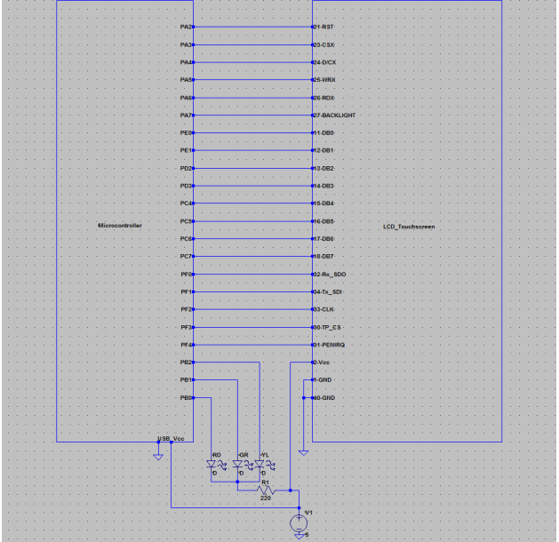

**Software details:**

After the initial configuration (drawing the LCD screen), the microcontroller did nothing (but could have been computing pi) while it waited to be interrupted by input from the user. The interrupt was configured for a logic low, so the interrupt continued to be triggered for as long as the user touched the screen. This removed any problems for touching and holding. For each interrupt, the microcontroller asked the touchscreen for the X and Y coordinates of the input, and added to a total value and count. When the user stopped touching the screen, the interrupts ceased and the total values for both X and Y were divided by the number of coordinates to get the average. It was this value that was used to determine the input location.

Once the location of input was known, and quick check on the bounds of X and Y determined if the location fell within the squares and if so which one. If yes, the state of the box and the LED changed to the appropriate value. The following flowchart shows the design logic:

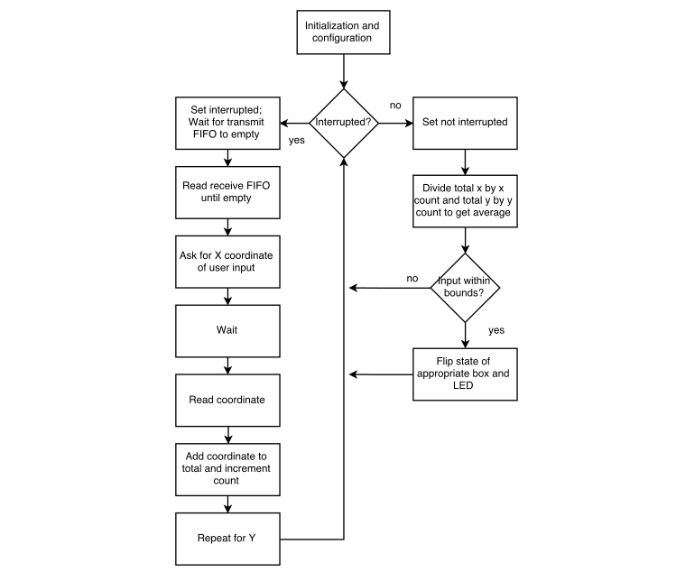

**SPI (SSI):**

Due to previous wiring and laziness, we used Port F's alternate function for the SPI module at about 2 MHz (66.67 MHz / 14), because that's what worked and there was no reason to change it. The clock was set to 66.67 MHz because we couldn't figure out how to make it faster. Everything worked quite well at that speed although we wish it was faster because the redrawing is still visible to the eye.

**Requirements:**

1. Three buttons must be drawn on the LCD. One red, one green, and one yellow. The buttons will

be blank colored outlines initially (like the red and yellow button in figure 1).

2. When a button is touched the button will be filled (like the green button in figure 1). When that

button is touched again the button should be return to a blank outline.

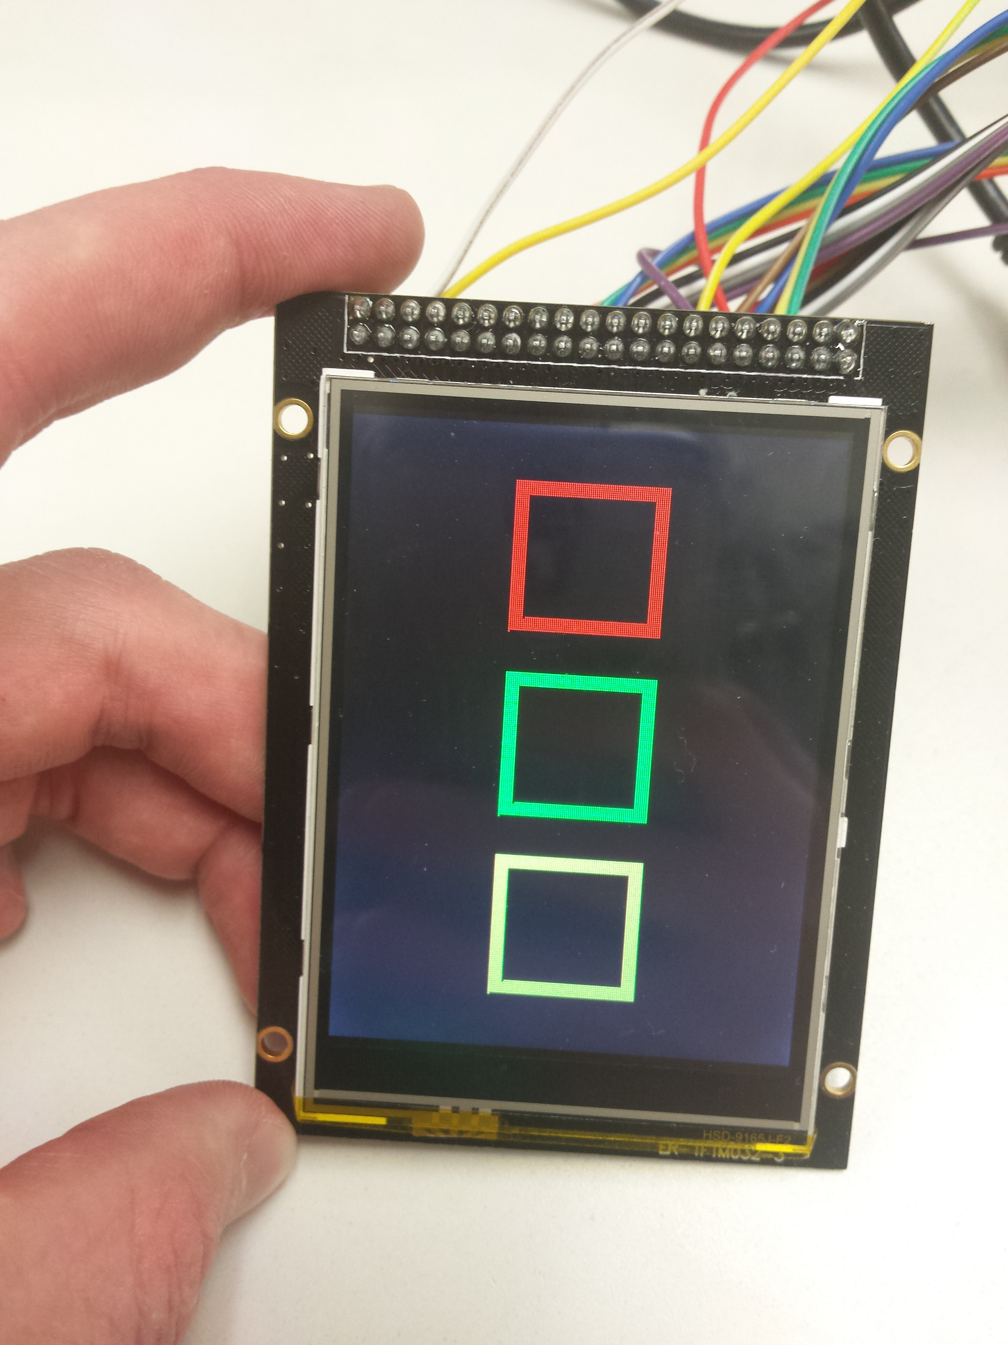

3. The red, green, and yellow LEDs should be wired to three available ports for output. The LEDs

must be lit up with the corresponding LCD button. If the LCD button is solid, the LED should be

on and vice versa.

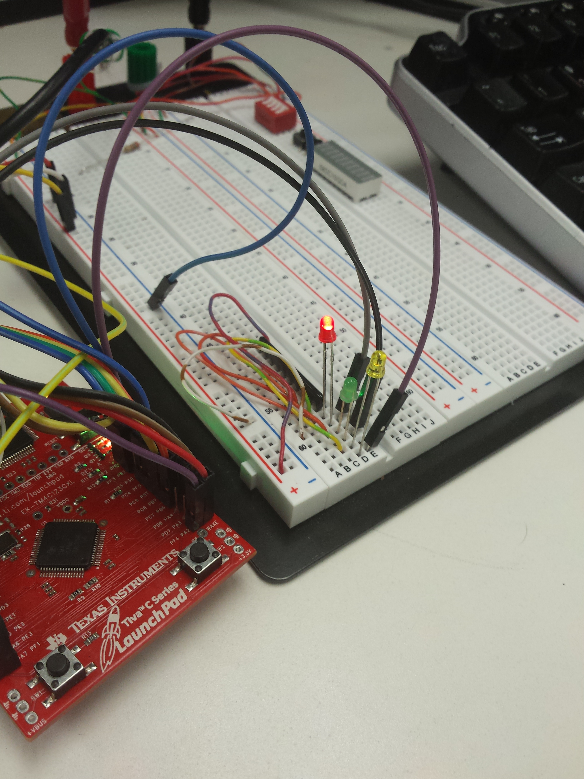

4. The screen refresh rate must be acceptably fast. What is the maximum clock rate that the

ILI9341 controller can handle?

As far as we know, the 66.67 MHz could be the maximum rate the LCD screen can handle. Below is a screenshot of data being written to the LCD screen. Write pin goes low, data goes onto the bus, write pin goes high:

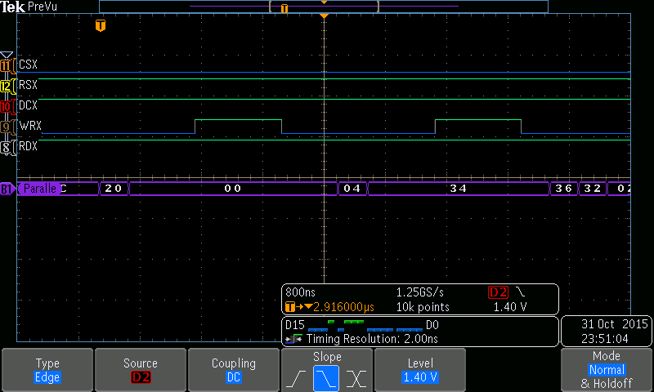

**Touchscreen:**

Upon being touched by the user, the touchscreen sent an interrupt request to the microcontroller, which then asked for X and Y coordinates from the user repeatedly until it stopped being touched. Here is a screenshot of the touchscreen sending those coordinates to the microcontroller. Towards the end, it is clear to see the data repeats itself for the second X coordinate (as it should):

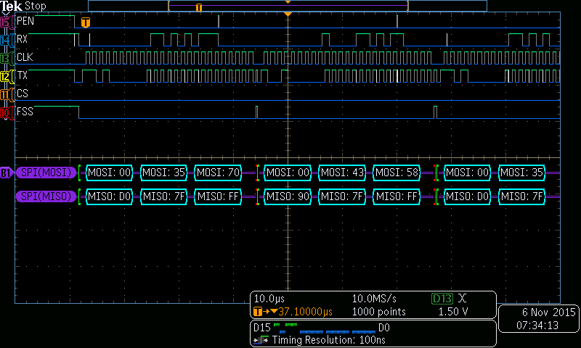

Below is a screenshot of a single coordinate being transmitted. The CSX (mislabeled) line represents when the receive FIFO is read. A faster configuration is probably possible, but this implementation worked just fine.

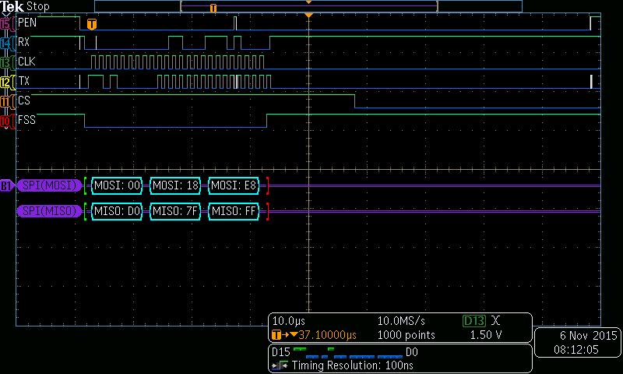

**Conclusion:**

The touchscreen is a little finicky and only works sometimes. The main reason for this is a poor design choice that allows the microcontroller to turn off the interrupt request by simply making the last bit written a logic '1', whether intentional or no. Otherwise, the response and accuracy of the touchscreen is quite high and although the refresh rate of the LCD is slow, it is still good quality.

**Code:**

The rest of this document contains only code. Here it is:

LCD.h

#ifndef LCD_H

#define LCD_H

// page 238 of the data sheet.

#define white 0xFFFF

#define black 0x0001

#define grey 0xF7DE

#define blue 0x001F

#define red 0xF800

#define magenta 0xF81F

#define green 0x07E0

#define cyan 0x7FFF

#define yellow 0xFFE0

#define ENDCOL 0x00EF //total columns

#define ENDPAGE 0x013F //total rows

#define OUTSQSC 0x52 //Outer square starting column (82)

#define OUTSQEC 0x9D //Outer square ending column (157)

#define INSQSC 0x59 //Inner square starting column (92)

#define INSQEC 0x96 //Inner square ending column (147)

#define TOTALAREA 0x12C00 //total screen area

#define SQUAREAREA 0x15F9 //total area per square (75^2)

#define INNERSQAREA 0xE89 //total area for inner part of square (55^2)

#define LOWX 0x578 //1400

#define HIGHX 0xAF0 //2800

#define REDLY 0x190 //400

#define REDHY 0x3E8 //1000

#define GREENLY 0x514 //1300

#define GREENHY 0x7D0 //2000

#define YELLY 0x8FC //2300

#define YELHY 0xBB8 //3000

extern unsigned char *SYSCTL;

extern unsigned char *PA;

extern unsigned char *PB;

extern unsigned char *PC;

extern unsigned char *PD;

extern unsigned char *PE;

extern unsigned char *PF;

extern unsigned char *CORE;

extern unsigned char *TM0;

extern unsigned char *TM1;

extern unsigned char *TM2;

extern unsigned char *SSI1;

void writeCmd(unsigned char CMD);

void writeDat(unsigned char DAT);

void writeDat2(unsigned short DAT);

void writeDat4(unsigned int DAT);

void setArea(unsigned short x1, unsigned short x2, unsigned short y1, unsigned short y2);

void RGB(unsigned char RED, unsigned char GREEN, unsigned char BLUE);

void writeColor(unsigned short color);

void LCD_Init(void);

void drawSizeColor(unsigned int AREA, unsigned char RED, unsigned char GREEN, unsigned char BLUE);

void drawRedSquare(void);

void drawGreenSquare(void);

void drawYelSquare(void);

void drawRedEmpty(void);

void drawGreenEmpty(void);

void drawYelEmpty(void);

#endif

LCD.c

#include "LCD.H"

void drawRedSquare(void)

{

setArea(OUTSQSC, OUTSQEC, 0x1B, 0x66); //27,102

writeCmd(0x2C);

drawSizeColor(SQUAREAREA, 0xFF, 0x00, 0x00); //red

}

void drawGreenSquare(void)

{

setArea(OUTSQSC, OUTSQEC, 0x7A, 0xC5); //122,197

writeCmd(0x2C);

drawSizeColor(SQUAREAREA, 0x00, 0xFF, 0x00); //green

}

void drawYelSquare(void)

{

setArea(OUTSQSC, OUTSQEC, 0xD9, 0x124); //217, 292

writeCmd(0x2C);

drawSizeColor(SQUAREAREA, 0xFF, 0xFF, 0x00); //yellow

}

void drawRedEmpty(void)

{

setArea(INSQSC, INSQEC, 0x22, 0x5F); // 34, 95

drawSizeColor(INNERSQAREA, 0x00, 0x00, 0x01); //black

}

void drawGreenEmpty(void)

{

setArea(INSQSC, INSQEC, 0x81, 0xBE); // 129, 190

drawSizeColor(INNERSQAREA, 0x00, 0x00, 0x01); //black

}

void drawYelEmpty(void)

{

setArea(INSQSC, INSQEC, 0xE0, 0x11D); // 224, 285

drawSizeColor(INNERSQAREA, 0x00, 0x00, 0x01); //black

}

void drawSizeColor(unsigned int Area, unsigned char RED, unsigned char GREEN, unsigned char BLUE)

{

unsigned int k;

writeCmd(0x2C);

for(k = 0; k < Area; k++)

{

RGB(RED, GREEN, BLUE);

}

}

void writeCmd(unsigned char input)

{

PA[0x3FC] &= 0xEF; // D/CX = 0 -> command

PA[0x3FC] &= 0xDF; // WRX = 0 -> going to write

PE[0x3FC] = input & 0x3;

PD[0x3FC] = input & 0xF;

PC[0x3FC] = input & 0xF0;

PA[0x3FC] |= 0x20; // WRX = 1 -> reads on pos edge

PA[0x3FC] |= 0x10; // D/CX = 1 -> default

}

void writeDat(unsigned char input) // 1 byte

{

PA[0x3FC] &= 0xDF; // WRX = 0 -> going to write

PE[0x3FC] = input & 0x3;

PD[0x3FC] = input & 0xF;

PC[0x3FC] = input & 0xF0;

PA[0x3FC] |= 0x20; // WRX = 1 -> reads on pos edge

}

void RGB(unsigned char RED, unsigned char GREEN, unsigned char BLUE)

{

unsigned short color = ((RED & 0x1F) << 11);

color |= ((GREEN & 0x3F) << 5);

color |= (BLUE & 0x1F);

writeColor(color);

}

void writeColor(unsigned short color)

{

writeDat((color & 0xFF00) >> 8);

writeDat((color & 0xFF));

}

void setArea(unsigned short x1, unsigned short x2, unsigned short y1, unsigned short y2)

{

writeCmd(0x2A); //column address set, max 0xEF

writeDat( (x1 >> 8) ); //SC MSB

writeDat( (x1 & 0xFF) ); //SC LSB

writeDat( (x2 >> 8) ); //EC MSB

writeDat( (x2 & 0xFF) ); //EC LSB

writeCmd(0x2B); //page address set, max 0x13F

writeDat( (y1 >> 8) ); //SP MSB

writeDat( (y1 & 0xFF) ); //SP LSB

writeDat( (y2 >> 8) ); //EP MSB

writeDat( (y2 & 0xFF) ); //EP LSB

}

void LCD_Init()

{

int i;

writeCmd(0xCB);

writeDat(0x39);

writeDat(0x2C);

writeDat(0x00);

writeDat(0x34);

writeDat(0x02);

writeCmd(0xCF);

writeDat(0x00);

writeDat(0XC1);

writeDat(0X30);

writeCmd(0xE8);

writeDat(0x85);

writeDat(0x00);

writeDat(0x78);

writeCmd(0xEA);

writeDat(0x00);

writeDat(0x00);

writeCmd(0xED);

writeDat(0x64);

writeDat(0x03);

writeDat(0X12);

writeDat(0X81);

writeCmd(0xF7);

writeDat(0x20);

writeCmd(0xC0); //Power control

writeDat(0x23); //VRH[5:0]

writeCmd(0xC1); //Power control

writeDat(0x10); //SAP[2:0];BT[3:0]

writeCmd(0xC5); //VCM control

writeDat(0x3e); //¶Ô±È¶Èµ÷½Ú

writeDat(0x28);

writeCmd(0xC7); //VCM control2

writeDat(0x86); //--

writeCmd(0x36); // Memory Access Control

writeDat(0x48); //C8 //48 68ÊúÆÁ//28 E8 ºáÆÁ

writeCmd(0x3A);

writeDat(0x55);

writeCmd(0xB1);

writeDat(0x00);

writeDat(0x18);

writeCmd(0xB6); // Display Function Control

writeDat(0x08);

writeDat(0x82);

writeDat(0x27);

writeCmd(0xF2); // 3Gamma Function Disable

writeDat(0x00);

writeCmd(0x26); //Gamma curve selected

writeDat(0x01);

writeCmd(0xE0); //Set Gamma

writeDat(0x0F);

writeDat(0x31);

writeDat(0x2B);

writeDat(0x0C);

writeDat(0x0E);

writeDat(0x08);

writeDat(0x4E);

writeDat(0xF1);

writeDat(0x37);

writeDat(0x07);

writeDat(0x10);

writeDat(0x03);

writeDat(0x0E);

writeDat(0x09);

writeDat(0x00);

writeCmd(0XE1); //Set Gamma

writeDat(0x00);

writeDat(0x0E);

writeDat(0x14);

writeDat(0x03);

writeDat(0x11);

writeDat(0x07);

writeDat(0x31);

writeDat(0xC1);

writeDat(0x48);

writeDat(0x08);

writeDat(0x0F);

writeDat(0x0C);

writeDat(0x31);

writeDat(0x36);

writeDat(0x0F);

writeCmd(0x11); //Exit Sleep

for( i = 0; i < 20000; i++) { i++;}

writeCmd(0x29); //Display on

}

Main.c:

// This function draws three empty boxes. The user touches the box

// to fill the box and turn on a corresponding external light.

#include "LCD.H"

#include "stdbool.h"

unsigned char *SYSCTL = (unsigned char *) 0x400FE000;

unsigned char *PA = (unsigned char *) 0x40004000;

unsigned char *PB = (unsigned char *) 0x40005000;

unsigned char *PC = (unsigned char *) 0x40006000;

unsigned char *PD = (unsigned char *) 0x40007000;

unsigned char *PE = (unsigned char *) 0x40024000;

unsigned char *PF = (unsigned char *) 0x40025000;

unsigned char *CORE = (unsigned char *) 0xE000E000;

unsigned char *TM0 = (unsigned char *) 0x40030000;

unsigned char *TM1 = (unsigned char *) 0x40031000;

unsigned char *TM2 = (unsigned char *) 0x40032000;

unsigned char *SSI1 = (unsigned char *) 0x40009000;

unsigned int *SSIDR = (unsigned int *) 0x40009008;

//globals for TP interrupts, modified in GPIOF_Handler

volatile unsigned int CNTX = 0; //number of valid interrupts for x

volatile unsigned int CNTY = 0; // number of valid interrupts for y

volatile unsigned int SUMX = 0; //sum x coordinates of press

volatile unsigned int SUMY = 0; //sum y coordinates of press

volatile bool input = false;

void GPIOF_Handler(void);

void enableClock(void);

void enableSSI1(void);

void enablePortA(void);

void enablePortB(void);

void enablePortC(void);

void enablePortD(void);

void enablePortE(void);

void enablePortF(void);

void configurePorts(void);

void flipRed(void);

void flipGreen(void);

void flipYel(void);

int main(void)

{

volatile unsigned int xcoord;

volatile unsigned int ycoord;

unsigned int i;

//SSI1[0x020] = 0x02; // RTIC clear SSIICR... maybe

configurePorts();

LCD_Init();

setArea(0x00, ENDCOL, 0x00, ENDPAGE);

drawSizeColor(TOTALAREA, 0xFF, 0xFF, 0xFF); //white

drawSizeColor(TOTALAREA, 0x00, 0x00, 0x01); //black

//draw outlines

drawRedSquare();

drawGreenSquare();

drawYelSquare();

//default off

drawRedEmpty();

drawGreenEmpty();

drawYelEmpty();

while (1)

{

//SSI1[0x008] = 0xD0;

if(input){

input = false;

xcoord = SUMX / CNTX;

ycoord = SUMY / CNTY;

if(LOWX < xcoord && xcoord < HIGHX){

if(REDLY < ycoord && ycoord < REDHY){

flipRed();

}

else if(GREENLY < ycoord && ycoord < GREENHY){

flipGreen();

}

else if(YELLY < ycoord && ycoord < YELHY){

flipYel();

}

}

SUMX = 0;

SUMY = 0;

CNTX = 0;

CNTY = 0;

for(i = 0; i < 0xFFFF; i++);

}

}

}

volatile unsigned short RXX = 0x0000;

volatile unsigned short RXY = 0x0000;

void GPIOF_Handler(void)

{

unsigned char TX = 0xD0; //x coordinate request

unsigned j = 0;

while((SSI1[0x00C] & 0x1) == 0x0); //wait for transmit FIFO to be empty

while((SSI1[0x00C] & 0x4) == 0x4){ //while receive FIFO is not empty

RXX = SSIDR[0];

}

SSI1[0x008] = TX; //ask for x coordinate

for(j = 0; j < 0x1FF; j++); // wait for receive FIFO

RXX = SSIDR[0]; //read data

RXX = (RXX & 0x7FFF) >> 3; //disregard first bit

SUMX += RXX;

CNTX++;

TX = 0x90; //y coordinate request

while((SSI1[0x00C] & 0x2) == 0x0); //wait TNF = 0; TNF = 1, continue

while((SSI1[0x00C] & 0x4) == 0x4){

RXY = SSIDR[0]; //read data

}

SSI1[0x008] = TX; //ask for x coordinate

for(j = 0; j < 0x1FF; j++); //wait for receive FIFO

RXY = SSIDR[0]; //read data

RXY = (RXY & 0x7FFF) >> 3; //disregard first bit

SUMY += RXY;

CNTY++;

input = true;

PF[0x41C] |= 0x10; //ack

CORE[0x283] |= 0x40; //unpend

}

void enableClock(){

unsigned int i;

// *(int*)&SYSCTL[0x060] = 0x8E3D40; //sysclk 16MHz

*(int*)&SYSCTL[0x060] = 0x14E1540; //sysclk 66.67 MHz

for(i = 0; i < 0xFF; i++);

SYSCTL[0x608] = 0x3F; //enable PA PB PC PD PE PF

SYSCTL[0x61C] = 0x02; // enable SSI1

__asm__ {nop};

__asm__ {nop};

__asm__ {nop};

}

void enableSSI1(void)

{

SSI1[0x004] = 0x00; // SSICR1 SSI disable

SSI1[0xFC8] = 0x00; // SSICC = SYSCLK

SSI1[0x010] = 0x0A; // SSICPSR (clk prescale) CPSDVSR = 2

// SSICR0 SCR = 1 -> ~22.22 MHz / ( 2 * (1 + 1))

*(int*)&SSI1[0x000] = 0x62E; // SSICR0 Microwire, 16bits, SCR = 7

SSI1[0x004] = 0x02; // SSICR1 SSI enable

}

void configurePorts()

{

enableClock();

enablePortA();

enablePortB();

enablePortC();

enablePortD();

enablePortE();

enablePortF();

enableSSI1();

PA[0x3FC] = 0x00;

PB[0x3FC] = 0xFF;

PC[0x3FC] = 0x00;

PD[0x3FC] = 0x00;

PE[0x3FC] = 0x00;

PA[0x3FC] |= 0xC4; //RESET and RDX high

PA[0x3FC] &= 0xF7; // CSX chip select low

PB[0x3FC] = 0x07; // LEDs active low, TP_CS low

//interrupts

PF[0x404] = 0x10; // PF4 level sensitive GPIOIS

PF[0x40C] = 0x00; // low level GPIOIEV

PF[0x410] = 0x10; // PF4 GPIOIM

CORE[0x103] = 0x40; // enable interrupts PF

}

void enablePortA(void)

{

PA[0x420] = 0x00; //AFSEL

PA[0x51C] = 0xFF; //DEN

PA[0x400] = 0xFC; //DIR

PA[0x514] = 0xFF; //PDR

}

void enablePortB(void)

{

PB[0x420] = 0x00; //AFSEL

PB[0x51C] = 0xFF; //DEN

PB[0x400] = 0xFF; //DIR

PB[0x514] = 0xFF; //PDR

}

void enablePortC(void)

{

PC[0x51C] = 0xFF; //DEN

PC[0x400] = 0xFF; //DIR

PC[0x514] = 0xFF; //PDR

}

void enablePortD(void)

{

*(int*)&PD[0x520] = 0x4C4F434B; //GPIO Unlcok

PD[0x524] = 0x80; //Commit register

PD[0x51C] = 0xFF; //DEN

PD[0x400] = 0xFF; //DIR

PD[0x514] = 0xFF; //PDR

}

void enablePortE(void)

{

PE[0x51C] = 0xFF; //DEN

PE[0x400] = 0xFF; //DIR

PE[0x514] = 0xFF; //PDR

}

void enablePortF(void)

{

*(int*)&PF[0x520] = 0x4C4F434B; //GPIO Unlock

PF[0x524] = 0x01; //Commit register

PF[0x420] = 0x0F; //AFSEL

PF[0x51C] = 0x1F; //DEN

PF[0x400] = 0x0E; //DIR - PF0 input

PF[0x510] = 0x1D; //PUR

PF[0x514] = 0x02; //PDR

// PF[0x50C] = 0x02;

*(int*)&PF[0x52C] = 0x00002222; //PCTL - SSI1

}

void flipRed(void)

{

//PB0

unsigned char val = (PB[0x3FC] & 0x1);

if(val == 0x1){

drawRedSquare();

PB[0x3FC] &= 0xFE;

}

else{

drawRedEmpty();

PB[0x3FC] |= 0x1;

}

}

void flipGreen(void)

{

//PB1

unsigned char val = (PB[0x3FC] & 0x2);

if(val == 0x2){

drawGreenSquare();

PB[0x3FC] &= 0xFD;

}

else{

drawGreenEmpty();

PB[0x3FC] |= 0x2;

}

}

void flipYel(void)

{

//PB2

unsigned char val = (PB[0x3FC] & 0x4);

if(val == 0x4){

drawYelSquare();

PB[0x3FC] &= 0xFB;

}

else{

drawYelEmpty();

PB[0x3FC] |= 0x4;

}

}

// PA2 - RST

// PA3 - CSX

// PA4 - D/CX

// PA5 - WRX

// PA6 - RDX

// PA7 - Backlight

// PB0 - Red LED

// PB1 - Green LED

// PB2 - Blue LED

// PB3 - TP_CS pin 30

// PF - SSI1

// PF0 - Rx - SDO pin 32

// PF1 - Tx - SDI pin 34

// PF2 - Clk - CLK pin 33

// PF3 - Fss - TP_CS pin 30

// PF4 - PENIRQ - IRQ pin 31